Given the roots of two binary trees p and q, write a function to check if they are the same or not.
Two binary trees are considered the same if they are structurally identical, and the nodes have the same value.

Example 1:
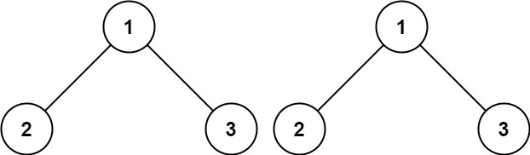
Input: p = [1,2,3], q = [1,2,3]
Output: true
Example 2:
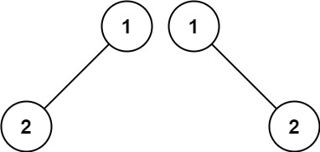
Input: p = [1,2], q = [1,null,2]
Output: false
Example 3:
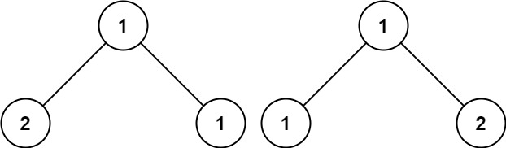
Input: p = [1,2,1], q = [1,1,2]
Output: false

APP:
->just traverse left and right and check whether it is same or not

CODE : TC:O(N) , SC:O(N) if balanced O(log N)
class Solution {
public boolean isSameTree(TreeNode p, TreeNode q) {
if(p==null && q==null)
return true;

else if((p==null && q!=null )||
(p!=null && q==null))
return false;

return p.val==q.val &&
isSameTree(p.left , q.left) &&
isSameTree(p.right , q.right);
}
}

LC#101 SYMMETRIC BINARY TREE:
Given the root of a binary tree, check whether it is a mirror of itself (i.e., symmetric around its center).

Example 1:
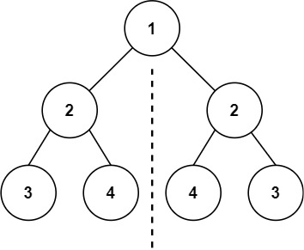
Input: root = [1,2,2,3,4,4,3]
Output: true
Example 2:
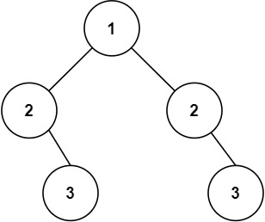
Input: root = [1,2,2,null,3,null,3]
Output: false

APP:
->check whether left.left ==right.right && left.right==right.left
->handling null cases is important
CODE: TC:O(N) , SC:O(N)
class Solution {
public boolean check(TreeNode leftNode , TreeNode rightNode)
{
if(leftNode ==null && rightNode ==null)
return true;

else if ((leftNode==null && rightNode!=null)||
(leftNode!=null && rightNode==null))
return false;
//the above can be replaced by this
//if(leftNode==null || rightNode==null)
//return leftNode==rightNode;
return leftNode.val == rightNode.val &&
check(leftNode.left , rightNode.right) &&
check(leftNode.right , rightNode.left);
}

public boolean isSymmetric(TreeNode root) {
if(root==null)
return true;

return check(root , root);
}
}
Given two integer arrays preorder and inorder where preorder is the preorder traversal of a binary tree and inorder is the inorder traversal of the same tree, construct and return the binary tree.

Example 1:
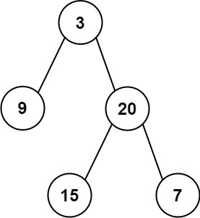
Input: preorder = [3,9,20,15,7], inorder = [9,3,15,20,7]
Output: [3,9,20,null,null,15,7]
Example 2:
Input: preorder = [-1], inorder = [-1]
Output: [-1]

APP:
->define globally the hm and preindex or else pass it to the function(makes param big)
->compute the root.left and root.right using merge sort kinda thing because
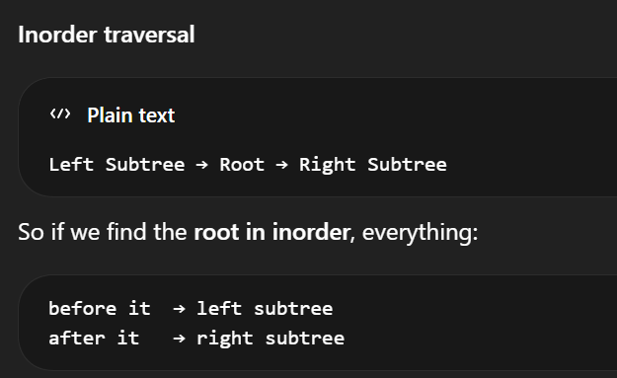

CODE: TC:O(N) SC :O(N) WITHOUT HM :O(N^2)
class Solution {
int preIndex = 0;
HashMap<Integer, Integer> hm = new HashMap<>();
public TreeNode buildTree(int[] preorder, int[] inorder) {
for(int i = 0 ; i< preorder.length ; i++)
hm.put(inorder[i] , i);

return build(preorder , 0 , inorder.length-1);
}

public TreeNode build(int[] preorder , int left , int right)
{
if(left>right)
return null;

int rootVal = preorder[preIndex];
preIndex++;
TreeNode root = new TreeNode(rootVal);

int idx = hm.get(rootVal);
root.left = build(preorder , left , idx-1);
root.right = build(preorder , idx+1 , right);

return root;

}
}

LC#114 FLATTEN BINARY TREE TO LINKED LIST
Given the root of a binary tree, flatten the tree into a "linked list":
- The "linked list" should use the same TreeNode class where the right child pointer points to the next node in the list and the left child pointer is always null.
- The "linked list" should be in the same order as a pre-order traversal of the binary tree.

Example 1:
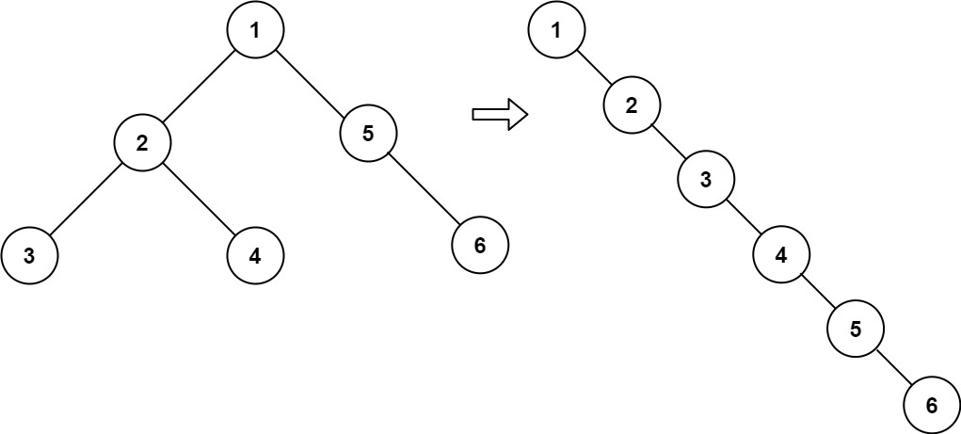
Input: root = [1,2,5,3,4,null,6]
Output: [1,null,2,null,3,null,4,null,5,null,6]
APP:
->although it may see simple but it is tough because of the node change
->go till last flatten the right side first
Flatten:
->match the root.right to prev
->root.left to null
->then get the currNode by prev = root because of recursion

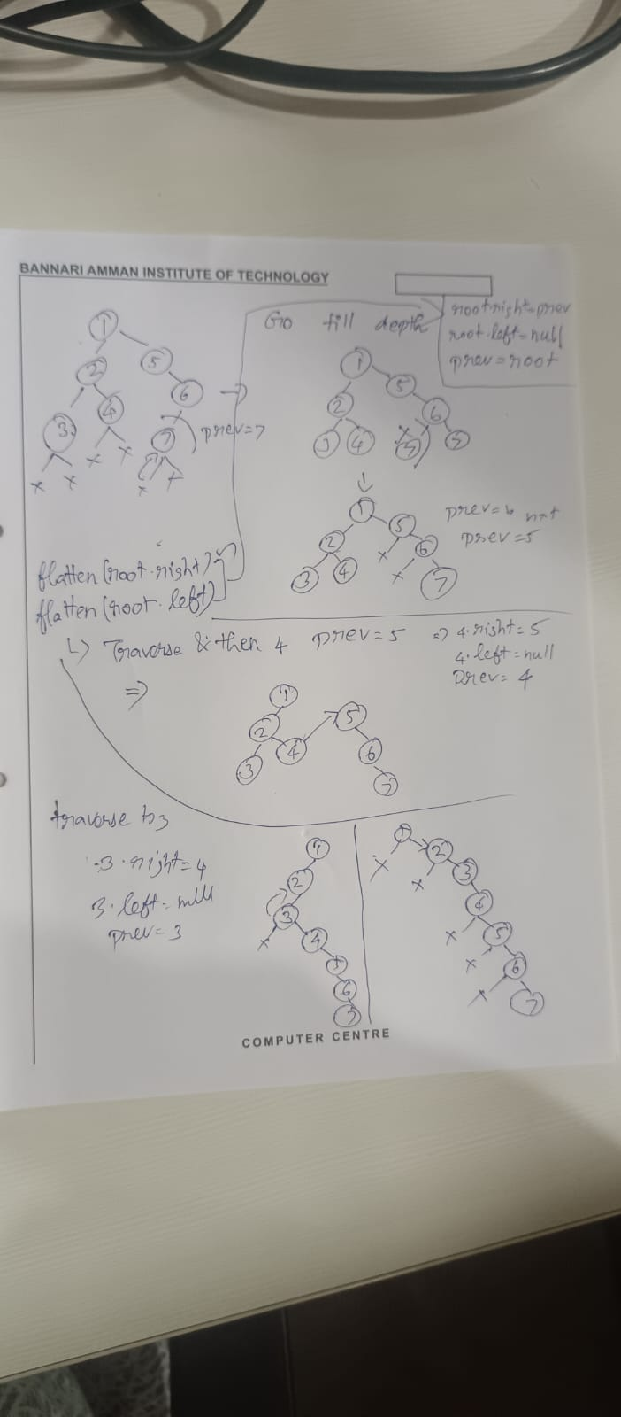
class Solution {
TreeNode prev = null ;
public void flatten(TreeNode root) {
if(root==null)
return ;

flatten(root.right);
flatten(root.left);

root.right = prev;
root.left = null;
prev = root;
}
}

LC#266 INVERT BINARY TREE
Given the root of a binary tree, invert the tree, and return its root.

Example 1:
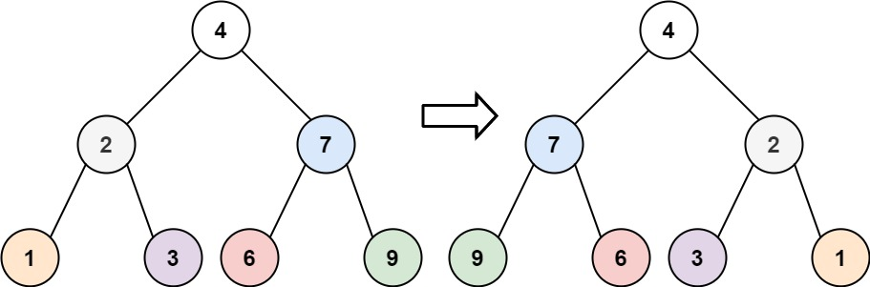
Input: root = [4,2,7,1,3,6,9]
Output: [4,7,2,9,6,3,1]
APP:
->normally traversal and perform a swap like normal temp variable we do right that like and then do the recursion for left and right and then return the root
CODE:
class Solution {
public TreeNode invertTree(TreeNode root) {
if(root==null)
return null;
TreeNode temp = root.left;
root.left = root.right;
root.right = temp;
invertTree(root.left);
invertTree(root.right);
return root;
}
}
LC#257 BINARY TREE PATHS:BACKTRACKING
Given the root of a binary tree, return all root-to-leaf paths in any order.
A leaf is a node with no children.

Example 1:
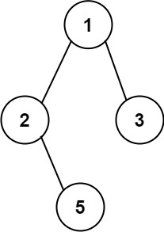
Input: root = [1,2,3,null,5]
Output: ["1->2->5","1->3"]
APP:
->use dfs initially append the value only else append the -> with the value
->if both left and right are null add and then backtrack

CODE: TC:O(N^2) -> O(N LOG N) IF BALANCED SC :O(N)
class Solution {
public List<String> binaryTreePaths(TreeNode root) {
List<String> res = new ArrayList();
dfs(root , "" , res);
return res;
}

public void dfs(TreeNode node , String path , List<String> res)
{
if(node==null)
return;

if(path.length()==0)
path+=node.val;
else
path+="->"+node.val;

if(node.left==null && node.right==null)
{
res.add(path);
return;
}

dfs(node.left , path , res);
dfs(node.right , path , res);
}
}

